1.0 Objectives
In this lab you will build the 8-bit program counter of the i281e processor on breadboards. This is a more complicated circuit, so be sure to double check your connections as you wire it.

2.0 Parts List

Quantity | Item
3 | White 830-point Breadboard
Set of | Breadboard Wire Spools | Or you could use a Pre-Cut Wire Kit
1 | Wire Cutters Electronic Grade
1 | Wire Strippers Electronic Grade
4 | CD74HCT283E Chip (4-bit adder)
2 | SN74HCT257N Chip (Quad 2-to-1 MUX)
1 | SN74HCT273N Chip (8-bit Register)
7 | 0.1 μF Ceramic Capacitor
1 | 5mm Red LED
7 | 5mm Green LED
2 | 5mm Yellow LED
10 | 330 Ω THT Resistor
2 | 16-Conductor Ribbon Cable, 8 to 12 inches long (AWG28-16/G/300)
4 | Connector for 16-position ribbon cable, DIP Header Connector (FDP-316-T)
1 | Breadboard Power Supply (e.g, YwRobot MB-V2)

3.0 Background
This section introduces the main components of the program counter circuit.

3.1 Ripple-Carry Adder
Figure 1 shows the high-level diagram for a 4-bit ripple-carry adder. It uses four full adders, each denoted with FA. By combining two 4-bit adders we can create an 8-bit adder. The program counter of the i281e processor uses two 8-bit adders (see Figure 3). Therefore, it needs four 4-bit adders that are connected as shown in Figure 4.
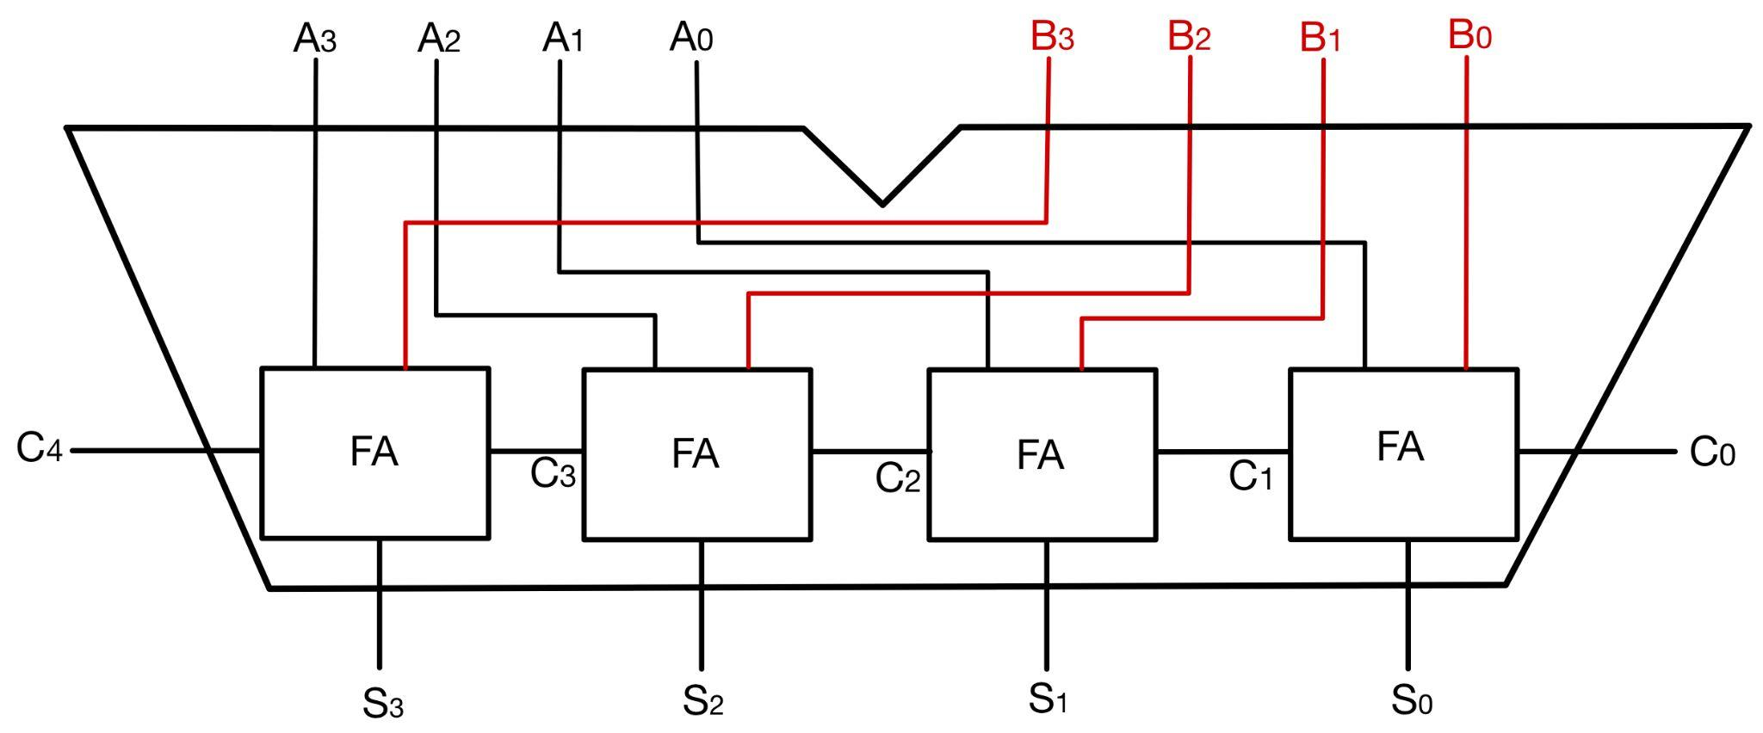
Figure 1: Block diagram of a 4-bit ripple-carry adder.

3.2 Bus Multiplexer
The program counter also uses an 8-bit 2-to-1 bus multiplexer. This component was the subject of Lab 3 and will not be discussed in detail here.

3.3 Register
Figure 2 shows the logic diagram for an 8-bit register implemented with eight D flip-flops that are connected to a common clock and reset/clear bit. This comes directly from the datasheet of the SN74HCT273N chip that you will use to implement the register. The purpose of this register is to store the address of the current CPU instruction in the code memory. This address will be referred to as PC. Its value is updated by the program counter circuit by adding 1 to it or by adding 1 plus an offset value, which comes from an external 8-bit bus.
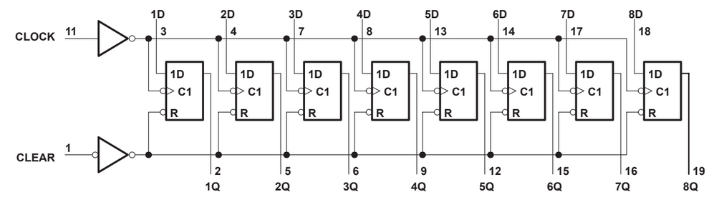
Figure 2: Logic diagram of the 8-bit parallel-load register implemented
by the SN74HCT273N chip. From the datasheet.

3.4 High-Level Diagram
Figure 3 shows a high-level diagram of the program counter circuit. It consists of two 8-bit adders, a 2-to-1 bus multiplexer (8-bits wide), and an 8-bit register. The top adder always adds 1 to the current value of the PC bus. This +1 is hard coded on one of its inputs as 00000001. The result of this addition is passed to the 0 input of the bus multiplexer. It is also passed to the second adder, which adds to it the 8-bit value on the offset bus. The sum bits of the second adder feed into the 1 input of the bus multiplexer.

Both adders have their C₀ input set to 0 by grounding it. Thus, they are always configured to add. If the offset value is negative (in 2’s complement representation) the equivalent operation for the second adder is subtraction, but it is performed as addition with a negative number.

The bus MUX is controlled by an external select line. When select is equal to 0, the MUX outputs PC + 1, i.e., the next address after the current PC. But when the select is equal to 1, the result is PC + 1 + offset. The result can be either larger or smaller than the current PC value.

The output from the MUX is stored into an 8-bit register on each positive edge of the clock signal. This value is passed onto the top adder for the next update. It also goes to the address line of the code memory (not shown in Figure 3), where it is always interpreted as an unsigned value. The$\underline{Reset}$ line is used to clear the register and to set the PC value to 0.

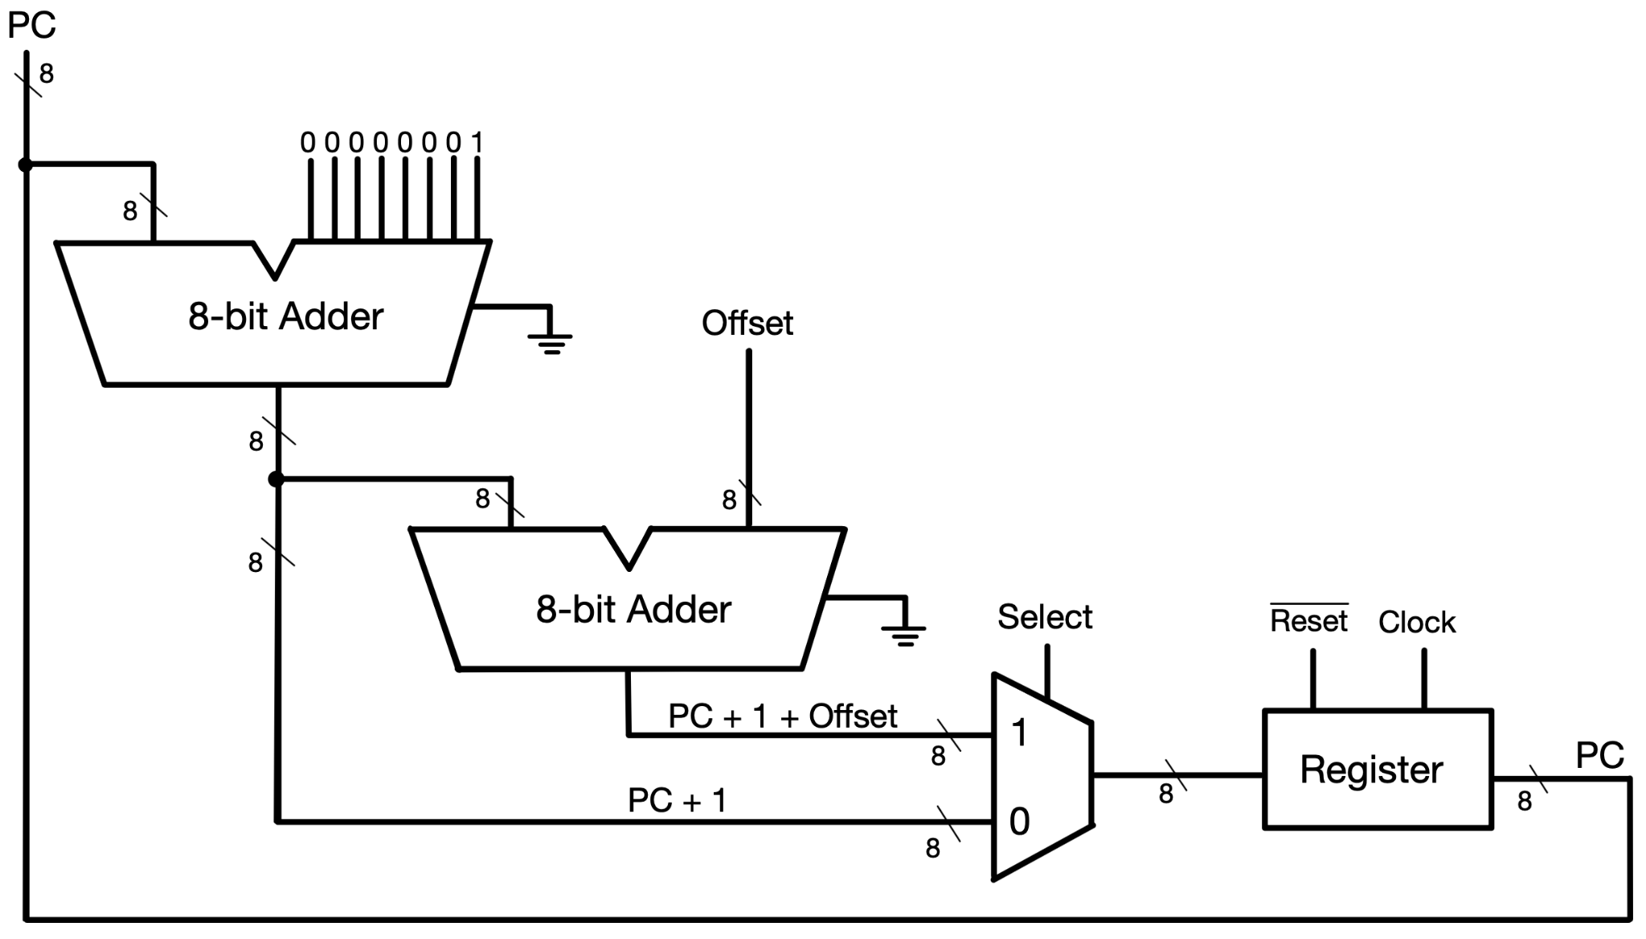
Figure 3: High-level diagram of the i281e program counter.

3.5 Circuit Accurate Diagram
Figure 4 shows the logic diagram of the circuit that you need to implement. This is a more accurate drawing than Figure 3, because it uses smaller components that directly map to the available chips. It shows how the components interact with each other. The two 8-bit adders are mapped to four 4-bit adders, labeled M1, L1, M2 and L2. Here M stands for most significant bits, while L stands for least significant bits. The sum bits of M1 and L1 combined hold the computed PC + 1 value. The outputs of M2 and L2 combined hold the PC + 1 + Offset value. The two multiplexers (called MUX M and MUX L) implement one 8-bit wide 2-to-1 bus multiplexer. The output of the MUX is saved in the register at the next positive edge of the clock.

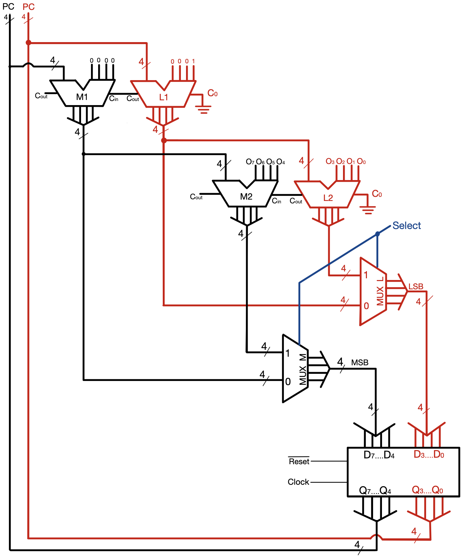
Figure 4: Circuit-accurate diagram of the program counter.

4.0 Activity

4.1 Place the Chips, LEDs, and Connectors
Get three breadboards and connect them along their long sides:
- Connect their power rails together with red wire.
- Connect the ground rails with black wire.
- Arrange the seven chips as shown in Figure 5.
- Then, follow the instructions given below.

Connect the chips to power and ground:
  - For all four adders, connect pin 8 to ground and pin 16 to power.
  - Repeat these steps for the two multiplexers.
  - Connect pin 15 of each multiplexer to ground (this enables the output).
  - For the register, connect pin 10 to ground and pin 20 to power.

Connect the 4-bit adders in pairs to form two 8-bit adders:
  - Connect pin 9 (C_{out}) of L1 to pin 7 (C_{in}) of M1.
  - Repeat this step for L2 and M2.
  - For both L1 and L2, set pin 7 (C_{in}) to ground. This sets C₀ to 0 for both adders.

Hard code the +1, which is 00000001 in binary:
  - For adder M1, ground pins 15, 11, 6, and 2.
  - For adder L1, ground pins 15, 11, and 2.
  - Connect pin 6 of L1 to power.
  - These connections are labeled with 0’s and 1 in Figure 5.

Place two bus connectors:
- These are labeled offset and PC in Figure 5.
- Don’t attach the ribbon cables yet.

Finally place the LEDs:
  - Connect a 330Ω resistor to each anode.
  - Ground each cathode.
  - Use a red LED for the least-significant bit.

Before continuing to the next step, have your circuit checked by the TA. It should be similar to the circuit shown in Figure 5.
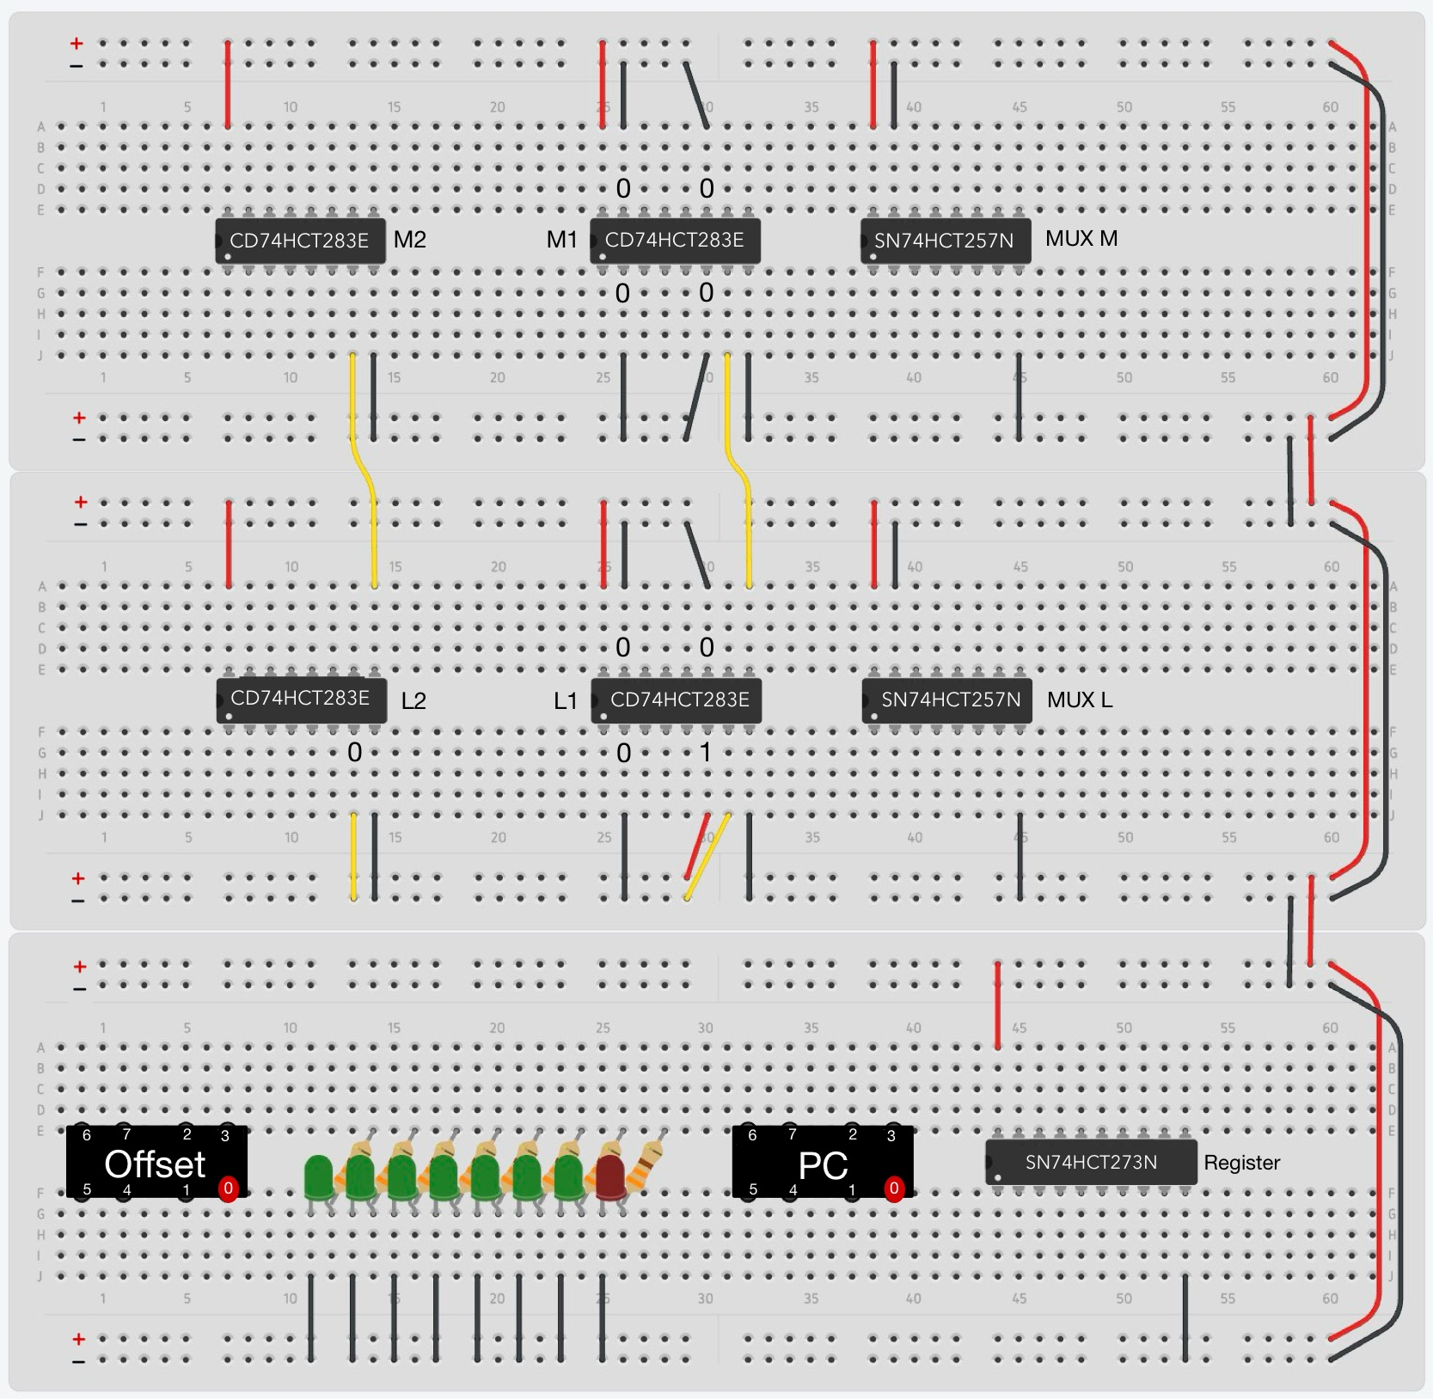
Figure 5: Place the chips and connect them to power and ground. Combine the 4-bit adders in vertical pairs to form two 8-bit adders. Hardcode the +1 value as 00000001. Add connectors, LEDs, and resistors.

4.2 Connect the Adders and MUXes
To minimize any wiring errors, please draw the 24 new connections in Figure 6 before you do anything on the breadboard. Use 3 different colors as indicated in the step-by-step instructions below.
Connect M2 to MUX M (blue wires in the top breadboard).
  - Pin 1 of M2 to pin 6 of MUX M
  - Pin 4 of M2 to pin 3 of MUX M
  - Pin 10 of M2 to pin 13 of MUX M
  - Pin 13 of M2 to pin 10 of MUX M
Connect M1 to MUX M (green wires in the top breadboard).
  - Pin 1 of M1 to pin 5 of MUX M
  - Pin 4 of M1 to pin 2 of MUX M
  - Pin 10 of M1 to pin 14 of MUX M
  - Pin 13 of M1 to pin 11 of MUX M
Connect M1 to M2 (magenta wires in the top breadboard).
  - Pin 1 of M1 to pin 3 of M2
  - Pin 4 of M1 to pin 5 of M2
  - Pin 13 of M1 to pin 14 of M2
  - Pin 10 of M1 to pin 12 of M2

Repeat the same steps for the middle breadboard. That is, connect L2 and L1 to MUX L using blue and green wires, respectively. Then, connect the sum bits of L1 to the A inputs of L2 with magenta wires. Double check your connections before continuing. Your circuit should be similar to the one shown in Figure 7.
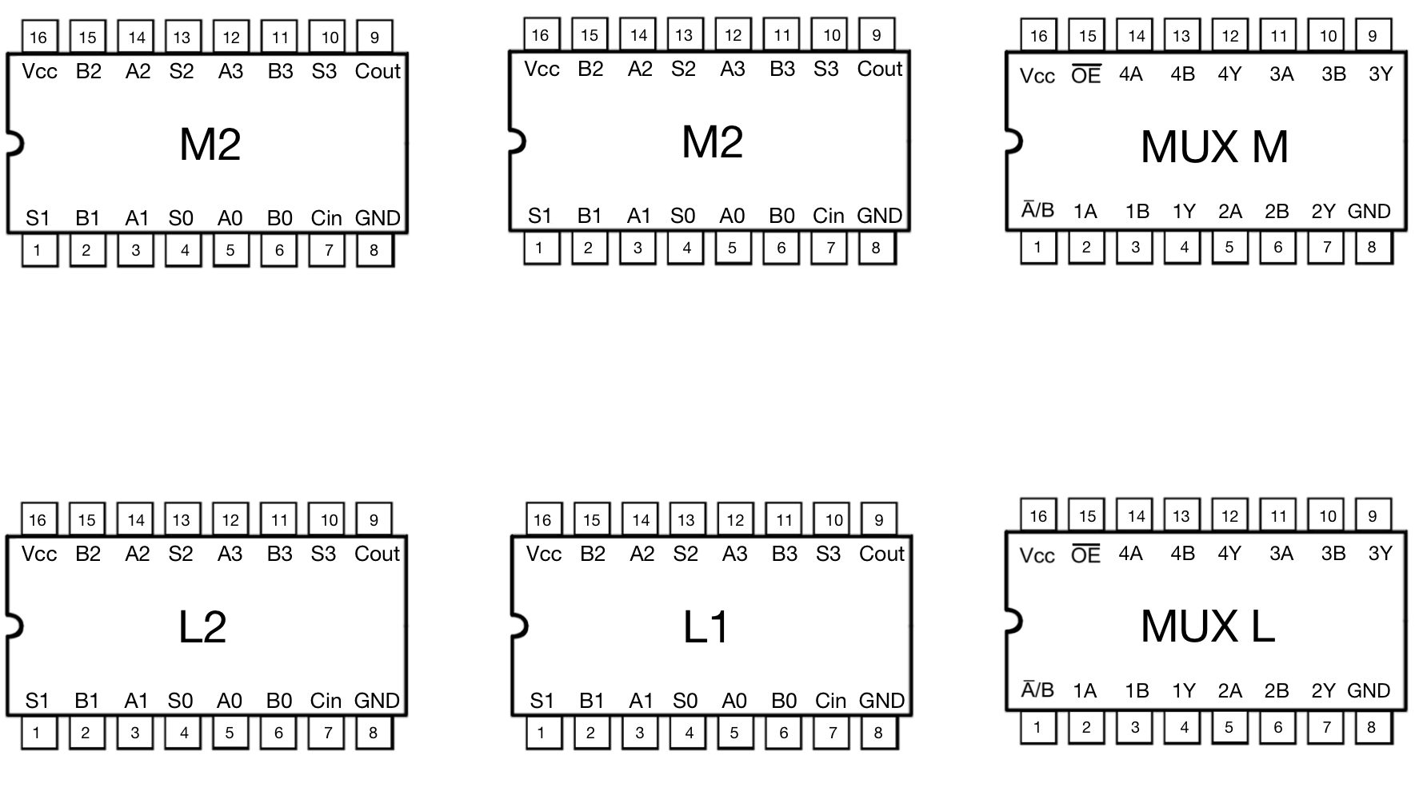
Figure 6: Draw the required connection on this diagram before wiring the breadboard.
Double check your connections before continuing.
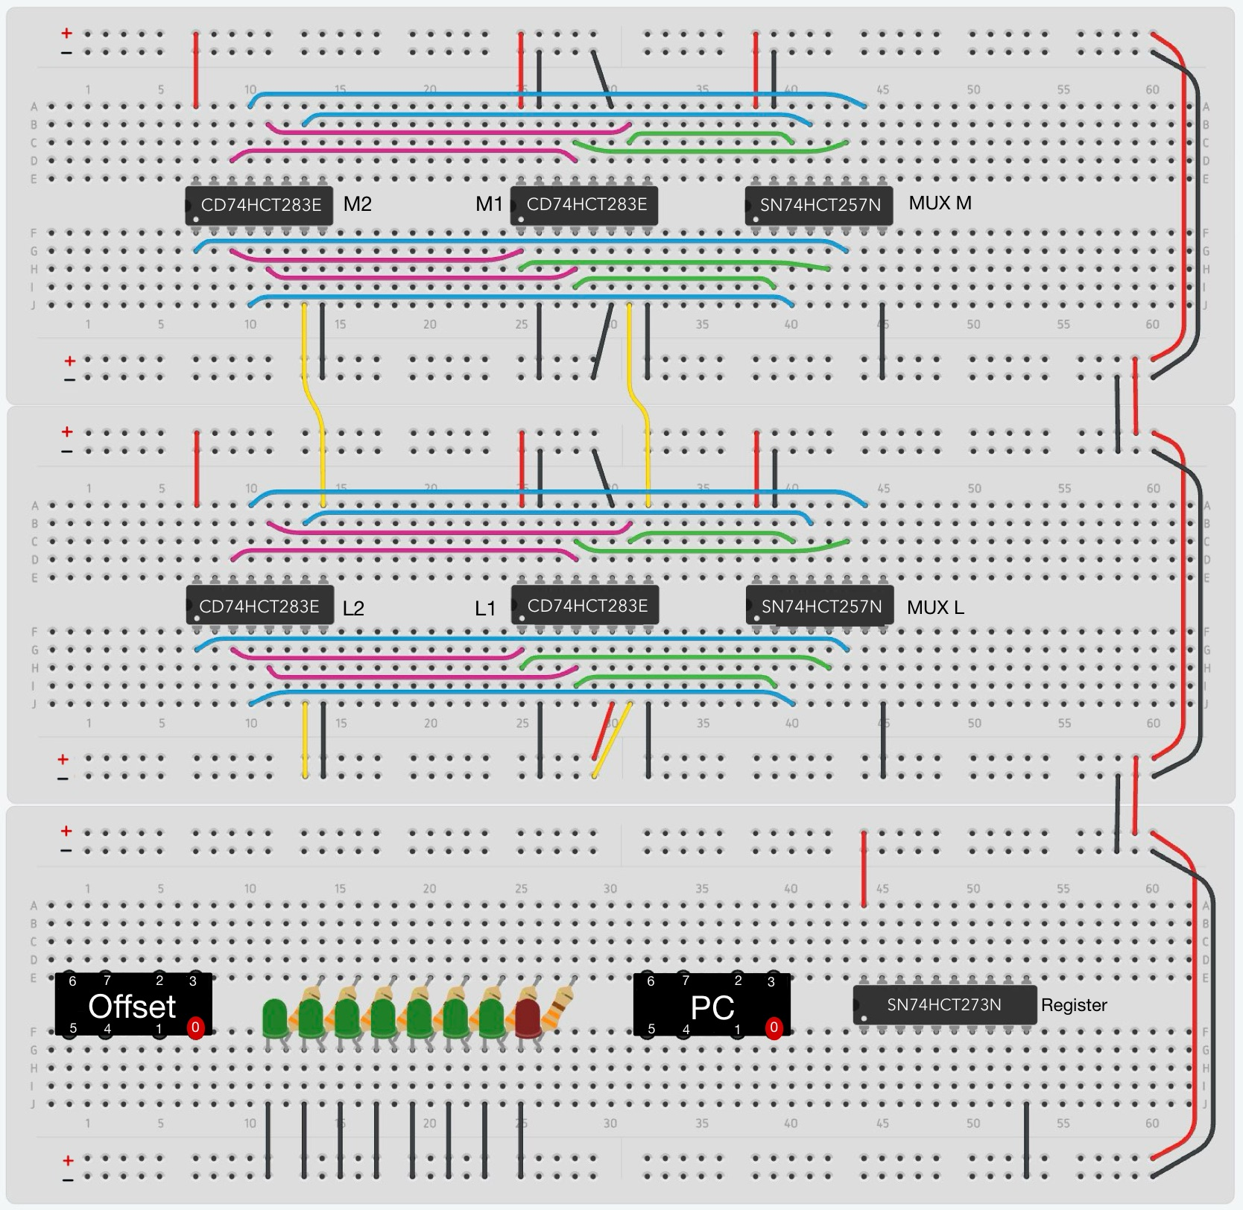
Figure 7: Connect the sum bits of the adders to the inputs of the MUXes.

4.3 Connect the Offset Bus and the PC Bus to the Adders
Please take another look at Figure 3 and Figure 4 before you proceed. They show the broader scope of the circuit that you are building.
Connect the Offset bus to the B inputs of adders M2 and L2 (orange wires in Figure 8).
- O0 to L2 pin 6
- O1 to L2 pin 2
- O2 to L2 pin 15
- O3 to L2 pin 11
- O4 to M2 pin 6
- O5 to M2 pin 2
- O6 to M2 pin 15
- O7 to M2 pin 11

Connect the PC bus to the A inputs of adders M1 and L1 (brown wires in Figure 8).
- PC0 to L1 pin 5
- PC1 to L1 pin 3
- PC2 to L1 pin 14
- PC3 to L1 pin 12
- PC4 to M1 pin 5
- PC5 to M1 pin 3
- PC6 to M1 pin 14
- PC7 to M1 pin 12

Double check your work. Your circuit should be similar to the one shown in Figure 8.
Before continuing to the next step, have your circuit checked by the TA.
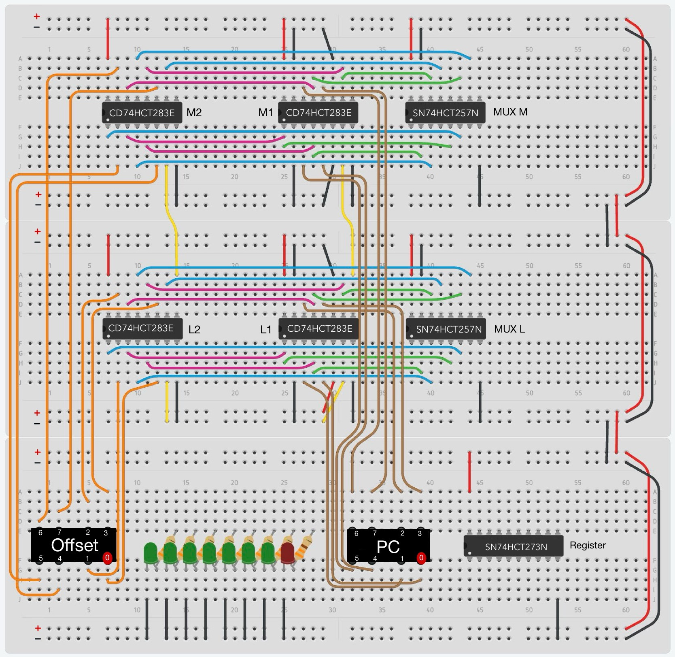
Figure 8: Connect the Offset bus and the PC bus to the adders.

4.4 Connect the Outputs of the Two MUXes to the Register
Please print this page and draw the 8 new connections on Figure 9 before wiring the real circuit.
Connect the Y outputs of MUX L to the D inputs of the Register (D₁, D₂, D₃, D₄).
  - MUX L pin 4 to Register pin 3
  - MUX L pin 7 to Register pin 4
  - MUX L pin 9 to Register pin 7
  - MUX L pin 12 to Register pin 8 (yes, pin 8 is correct! There is a typo in the spec sheet.)

Connect the Y outputs of MUX M to the D inputs of the Register (D₅, D₆, D₇, D₈).
  - MUX M pin 4 to Register pin 13
  - MUX M pin 7 to Register pin 14
  - MUX M pin 9 to Register pin 17
  - MUX M pin 12 to Register pin 18

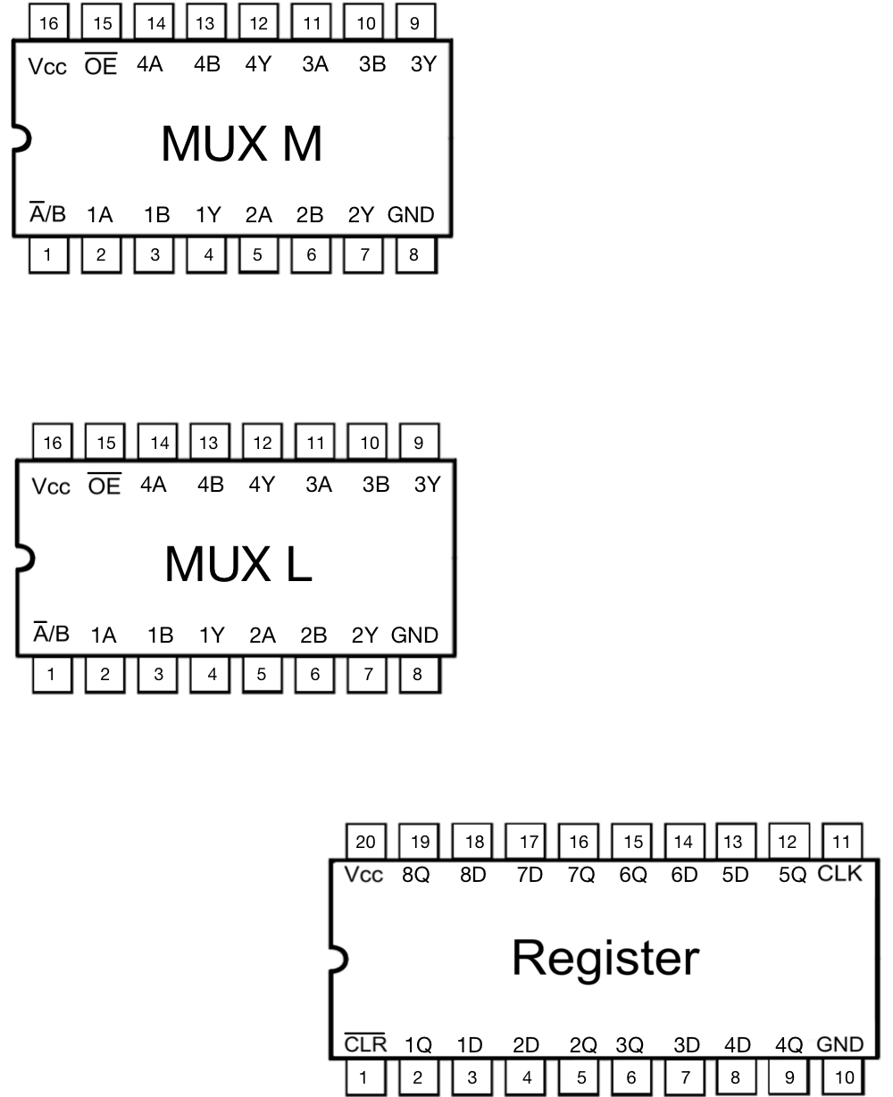

Figure 9: Draw the new connections on this diagram before placing the real wires.
Double check your connections before continuing. They should match the purple wires in Figure 10.

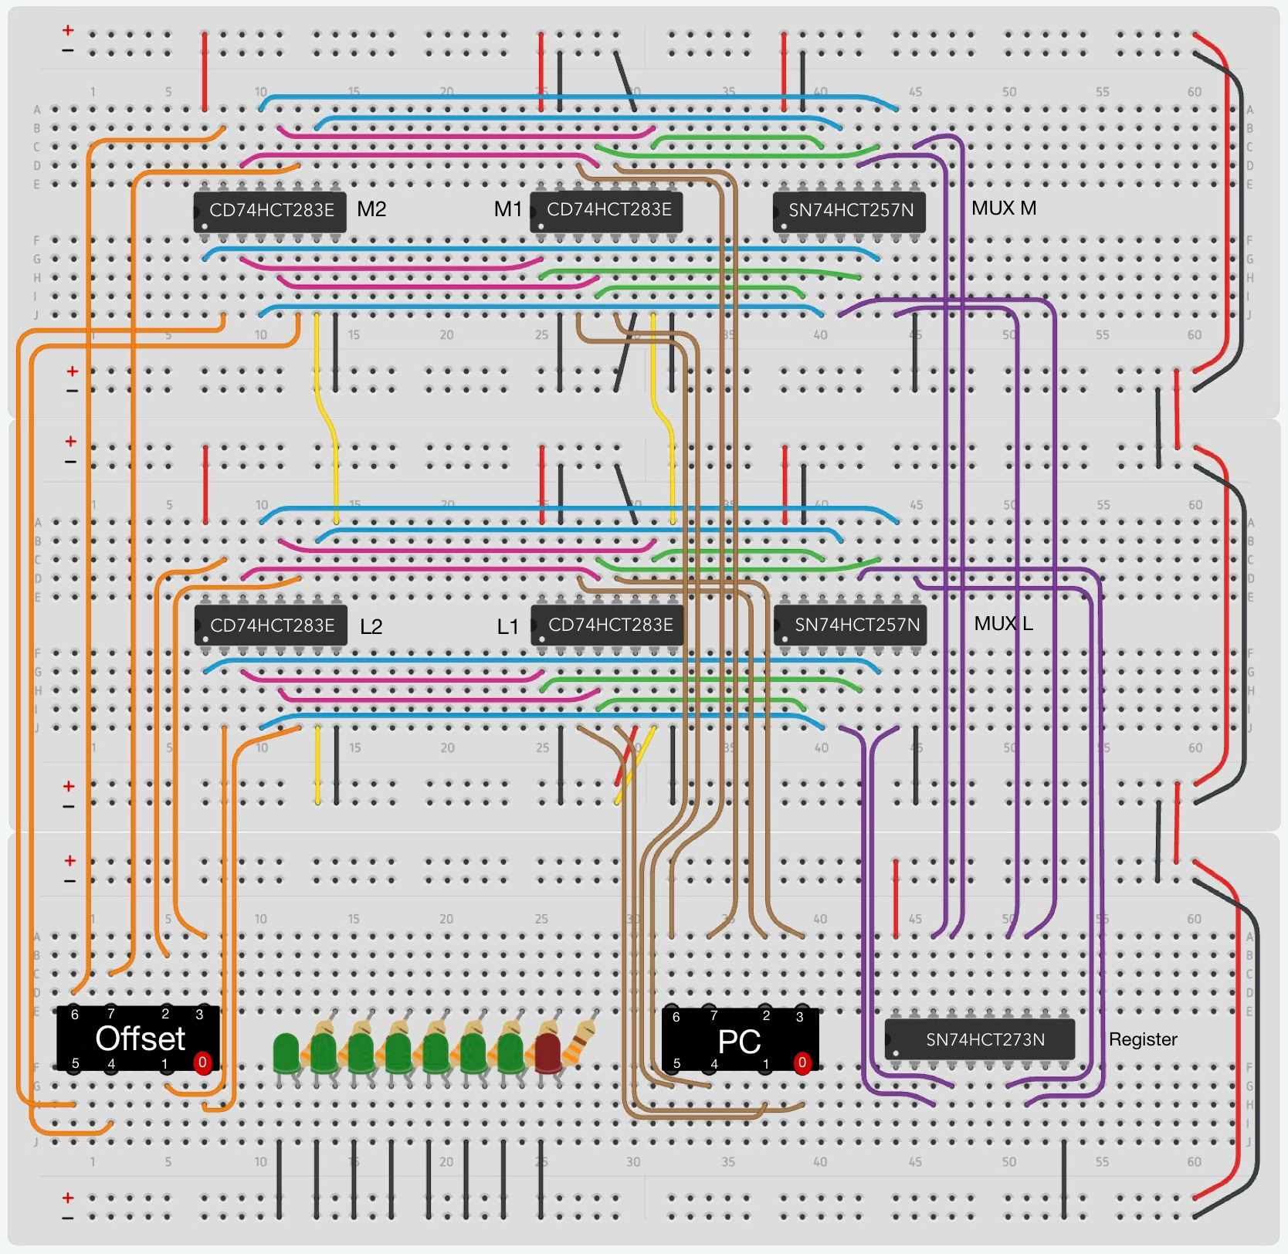
Figure 10: Connect the Y outputs of the MUXes to the D inputs of the register.

4.5 Connect the Output of the Register to the PC Bus and LEDs
Connect the Q outputs of the register to the pins of the PC connector. These are the gray wires in Figure 11. In more details:
  - Register pin 2 to PC0
  - Register pin 5 to PC1
  - Register pin 6 to PC2
  - Register pin 9 to PC3 (Pin 9 is correct! There is a type in the spec sheet.)
  - Register pin 12 to PC4
  - Register pin 15 to PC5
  - Register pin 16 to PC6
  - Register pin 19 to PC7

Connect the pins of the PC connector to the anodes of the LEDs through the resistors (from right to left). These are the magenta wires in the bottom breadboard in Figure 11. Specifically:
  - PC0 to red LED
  - PC1 to first green LED
  - PC2 to second green LED
  - PC3 to third green LED
  - PC4 to fourth green LED
  - PC5 to fifth green LED
  - PC6 to sixth green LED
  - PC7 to seventh green LED

Double check your connections before continuing to the next task. Also, compare your circuit with the one shown in Figure 11.

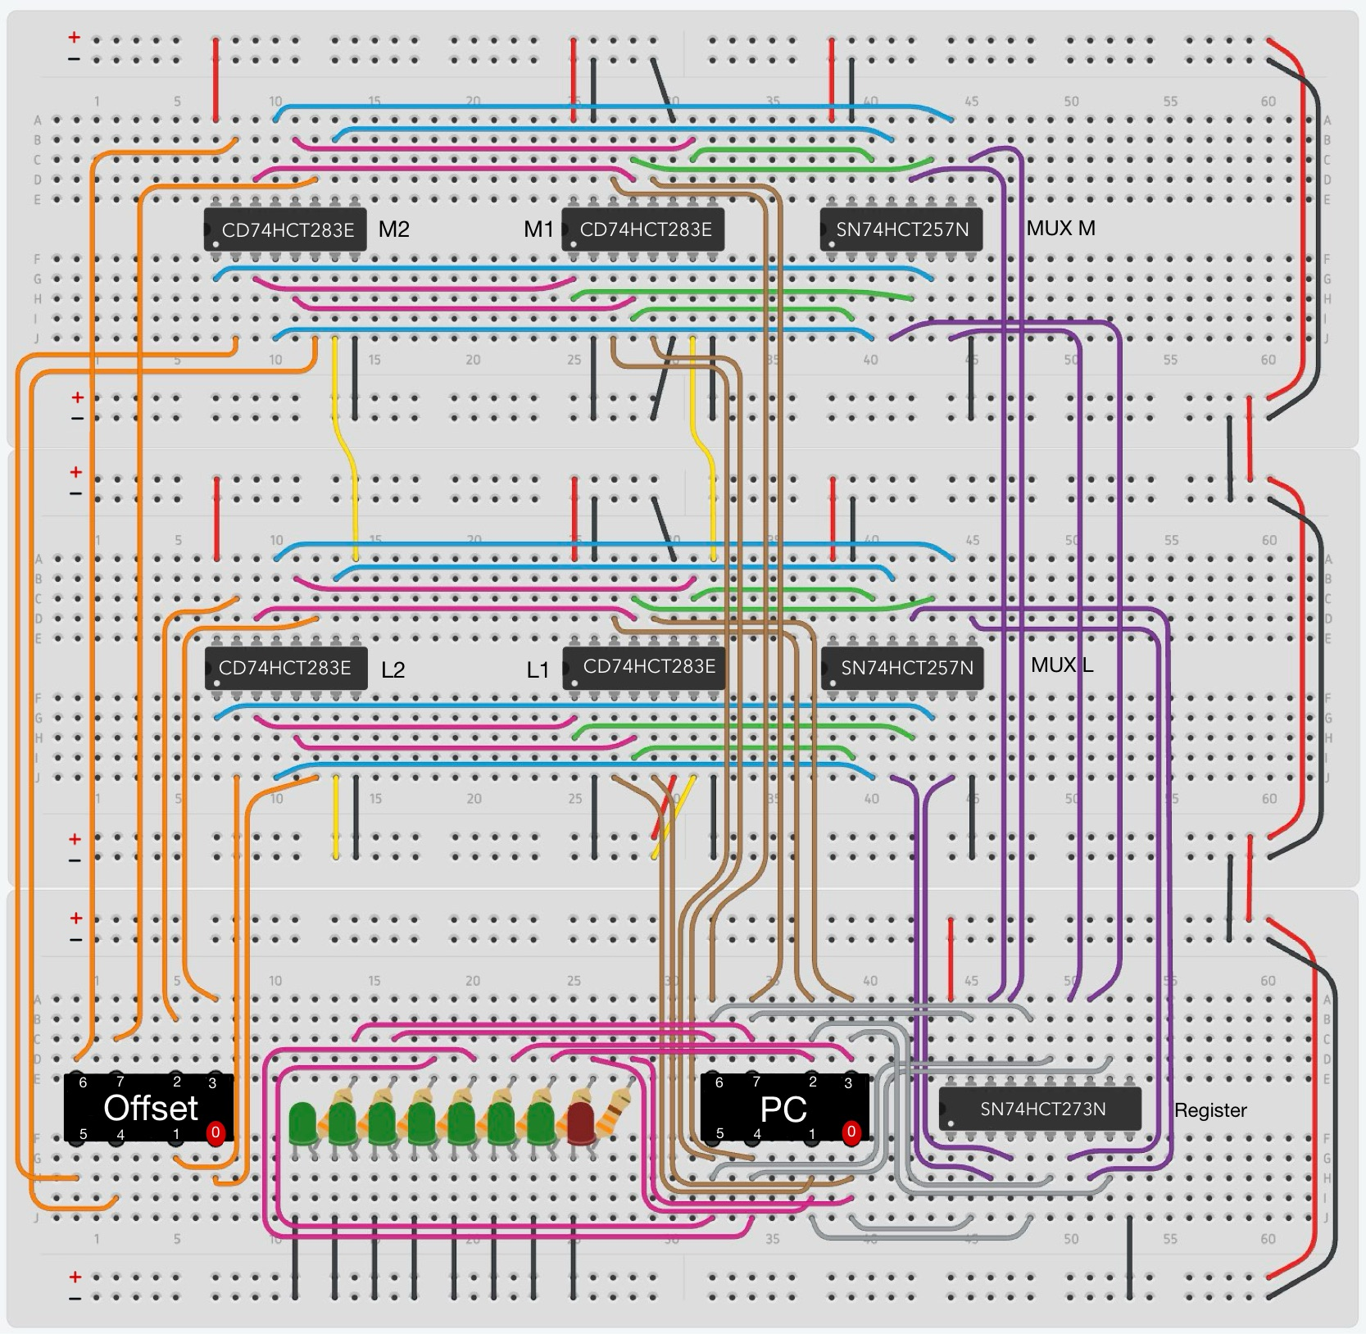
Figure 11: Connect the Q outputs of the Register to the PC bus and LEDs.

4.6 Finish the Circuit
Add the Select line:
  - Connect the select line to pin 1 of both the MUXes.
  - Additionally, visualize its value with a yellow LED.
  - Remember to place the anode of the LED after a 330Ω resistor and to ground the cathode.

Add the Clock line:
  - Connect the clock line to pin 11 on the register.
  - Visualize this line by also connecting it to a red LED.

Add the $\underline{Reset}$ line:
  - Connect the $\underline{Reset}$ line to pin 1 on the register. This is an active low signal.
  - Connect this line to a yellow LED.

Add a 0.1μF capacitor for each chip:
- For each MUX, place the capacitor between pins 15 and 16.
- For adders M1 and L1, place the capacitor between pins 15 and 16.
- For adders M2 and L2, place the capacitor between pin 16 and ground. Note that pin 15 is no longer grounded for these chips. Therefore, you need to place a new black wire to the left of pin 16 in order to do the grounding. See Figure 12.
- For the register, place the capacitor between pin 20 and ground. Here, you will need a new grounding wire as well.

When you are finished, your circuit should be similar to the one in Figure 12. Before continuing to the next step, have your circuit checked by the TA.

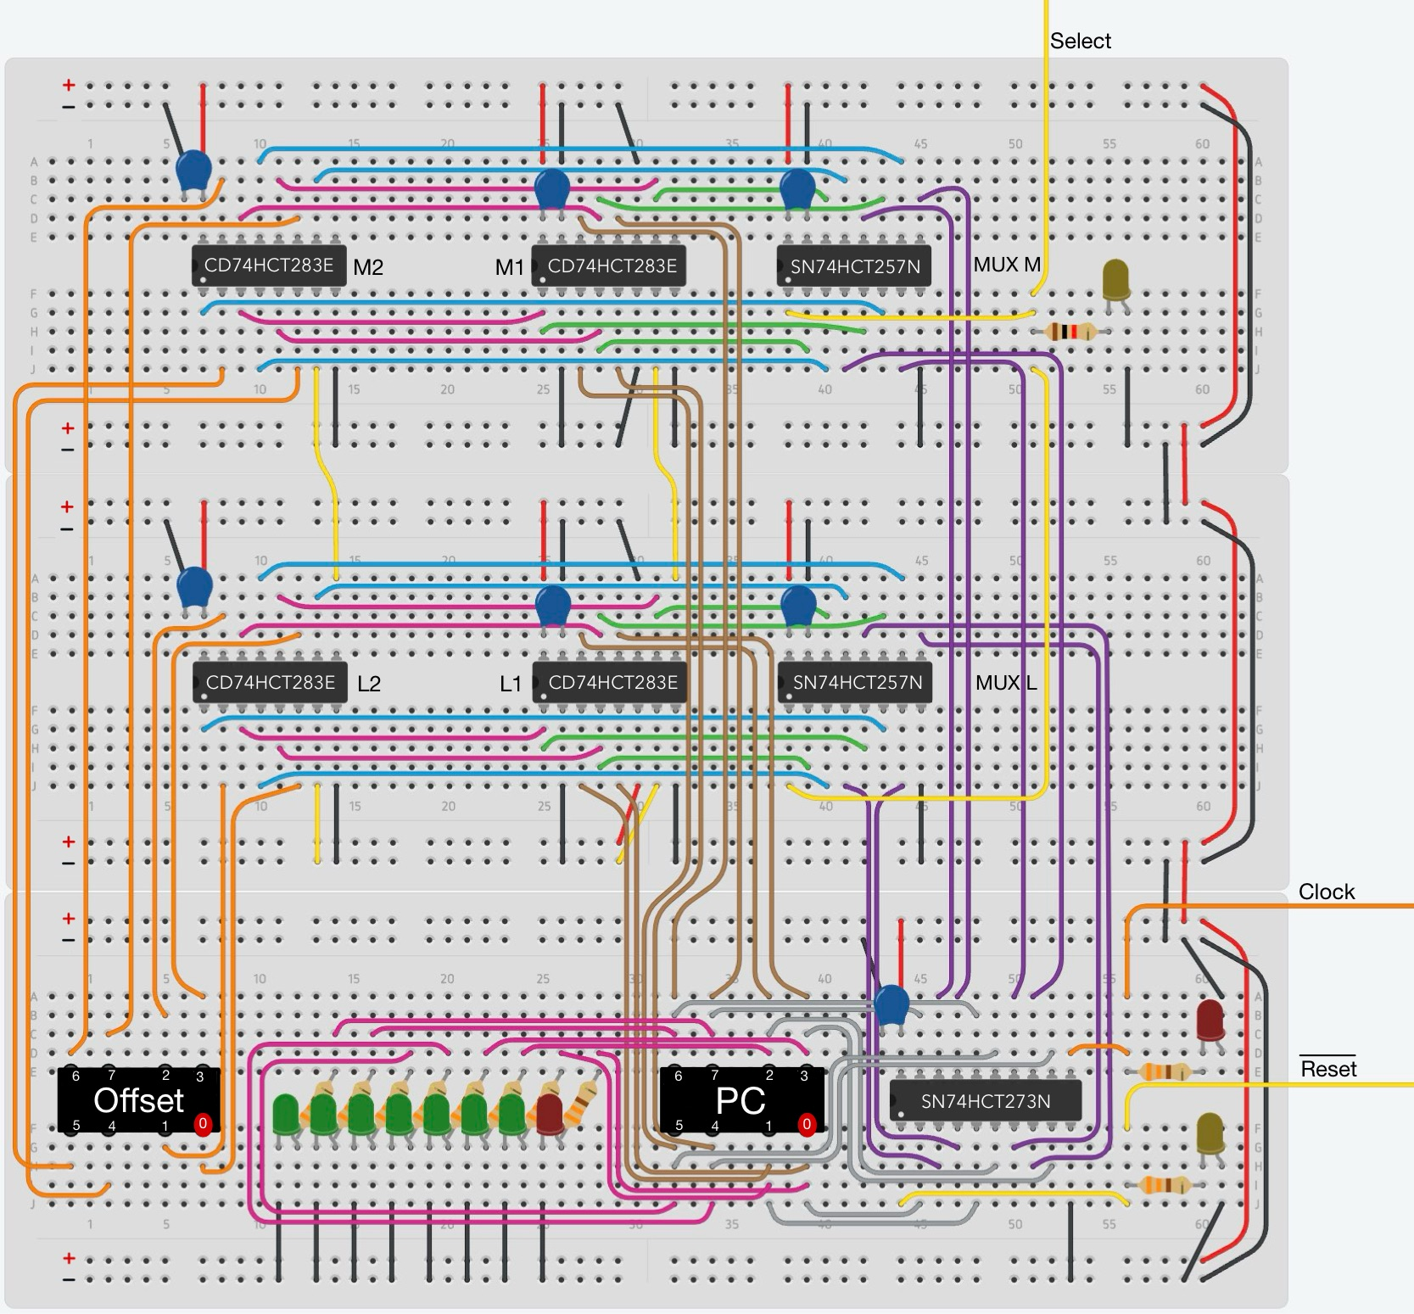
Figure 12: Add the external Select, Clock and $\underline{Reset}$ lines. Visualize each of them with an LED. Finish the circuit by adding a 0.1 μF capacitor for each chip.

5.0 Testing
Before the final testing check, your circuit for common mistakes such as loose connections, wires connecting to the wrong place, and flipped LEDs. Once you are certain that your circuit is correct, have the TA double check it before you turn on the power supply.

5.1 Connect the Program Counter to the Testing Circuit
Connect your circuit to the testing circuit as shown in Figure 13. The offset bus is an input. The PC bus is an output. Verify that the pins of the connectors line up correctly with the existing wires. In addition, ensure that the power and ground rails of the two circuits are connected together with two extra wires (see the middle of Figure 13).

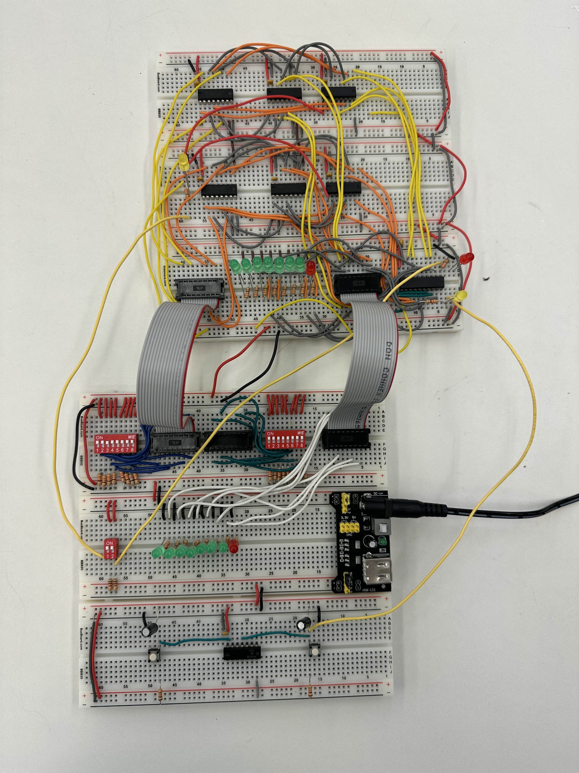
Figure 13: PC Circuit with testing circuit attached.

5.2 Functionality Tests
Perform the following tests using the testing circuit and show the results to the TA:
- Set the Select line to 0. Then, press the Clock button several times and verify that the PC increases by 1 each time (as indicated on the LEDs).
- Set the Select line to 1 using the DIP switches. Provide an 8-bit positive value on the Offset bus. Then, verify that the PC increments by offset + 1 every time you press the clock button.
- Set the Select line to 0. Verify that the PC continues to increment by 1 even if the offset value is not zero.
- Repeat tests 2 and 3 with a negative value (in 2’s complement) on the Offset bus.

5.3 Debugging Tips
If your circuit does not function as specified in 5.2, double check that it is hooked up to the testing rig correctly and that it does not have any of the common issues outlined in 5.0. Some other things to check:
- Is the Clock input connected to a debounced switch? Refer to lab 2 for why this may be causing issues.
- Is the $\underline{Reset}$ input connected to power? It should not be grounded.
- Did you forget to enable the outputs of the MUXes? Check that pin 15 of both is grounded.

